[ CS 201 Data Structures ] [ Fall 2008 ] [ Mid Term Exam 2 ] [ 7 Nov, 2008 ] [ Time Allowed: 90 mins ]
SOLUTIONS
QUESTION 1 8+2 Marks
Suppose we have a linear singly-linked list without sentinel/head nodes. Write a C++ function to swap two nodes of the list, pointed to by node pointers *p and *q. You have to swap the actual nodes and not the values inside the nodes. What is the complexity of your algorithm?

SOLUTION (note: this is not the only solution. You can come up with a better one)
//Suppose we have a pointer *start that points to the beginning of the list. In this question we have to find the previous of p and q in order to swap the actual nodes of the list.
//function will return false if p or q nodes are not found in the list or they point to the same nodes
bool LinkedList::Swap(node *p, node *q)
{
node *prev_p = NULL;
node *prev_q = NULL;
node *temp = Start;
//return false if p or q are null
if (!p || !q)
return false;
//loop should stop when either end of list is reached or prev_p and prev_q are both found
while(temp && (!prev_p || !prev_q))
{
if (temp->next == p)
prev_p = temp;
if (temp->next == q)
prev_q = temp;
temp = temp->next;
}

//check for special condition when we didn’t find p or q in the list
if (!prev_p && p!=Start)
return false;
if (!prev_q && q!=Start)
return false;

//now do the actual swap
if (prev_p) //its possible that p is head node
prev_p->next = q;
if (prev_q) //its possible that q is head node
prev_q->next = p;

temp = p->next;
p->next == q->next;
q->next = temp;
}
QUESTION 2 10 Marks
Write an iterative C++ function to count the number of nodes of degree two in a binary tree. You can assume that a queue or stack object is available and you can use their operations. Recursion is not allowed.

SOLUTION
//here you can use the iterative version of inorder, postorder, pre-order traversals using stacks or you can use level order traversal using a queue
//assume that we have a pointer to the root of a tree as a member of BinaryTree

int BinaryTree::countDegreeTwoNodes()
{
Stack S; //S has pointer to nodes as its elements
int count = 0;
if (!Root) //empty tree so return zero
return 0;

node *curr = Root;
S.push(curr);
while(!S.IsEmpty())
{
curr = S.pop();
if (curr->leftChild && curr->rightChild) //check if it’s a degree two node
count++;
if (curr->rightChild)
S.push(curr->rightChild);
if (curr->leftChild)
S.push(curr->leftChild);
}
return count;
}
//what is the traversal order of the above function

QUESTION 3 10 Marks
We have the following definition of a node in a binary tree:
class Node
{
int key;
Node *LeftChild, *RightChild;
friend class BinaryTree;
};
We have the following definition of a binary tree:
class BinaryTree
{
public:
// some methods here
// …
bool CheckBST();
private:
// add your data or methods here
};
Implement the CheckBST() method in C++ that returns true if the binary tree is a binary search tree, otherwise, it returns false. Note: you have to provide a recursive solution and if you use any other function in your solution, you have to implement it too. Global and static variables are not allowed.

SOLUTION
BinaryTree will have one private data member, i.e., root which is a pointer to the root. It will also have one private method CheckBST(node *n) (implemented below)

bool BinaryTree::CheckBST()
{
//here call the recursive version of this function
return CheckBST(root);
}

//this function will be a private member of BinaryTree

bool BinaryTree::CheckBST(node *n)
{
bool IsBST = true;

//if n is null we can return true as BST is allowed to be empty
if (n)
{
//check the current node and its immediate child nodes
if (n->LeftChild && n->key <= n->LeftChild->key)
IsBST = false;
if (IsBST && n->RightChild && n->key >= n->RightChild->key)
IsBST = false;

//now make a recursive call to check the left and right subtrees of n
if (IsBST)
IsBST = CheckBST(n->LeftChild) && CheckBST(n->RightChild);
}
return IsBST;
}
QUESTION 4 Marks: 4+3+3
4a. Create a min heap when inserting the following keys in the order given. Show both the array and linked representations:
10 2 9 1 7 5 4
Array: {NULL, 1, 2, 4, 10, 7, 9, 5} 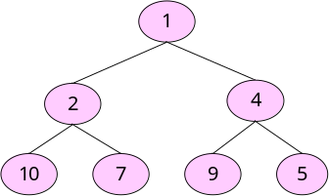

4b. What will the min heap look like after we insert a 7 and then a 0 in the heap above. Show both the array and linked representations after both insertions seperately (i.e. draw four diagrams).

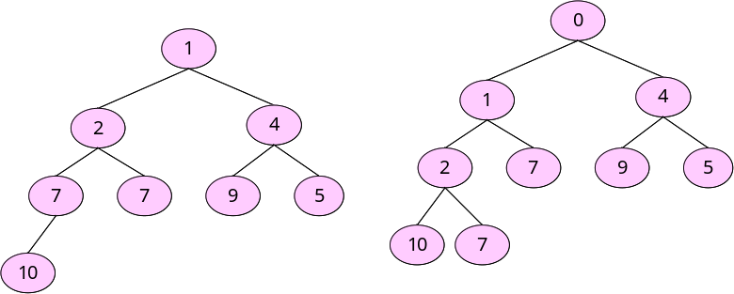
Array: {NULL,1,2,3,7,7,95,10} Array:{NULL,0,1,4,2,7,9,5,10,7}
4c. What will the min heap look like after two deletions. Show both the array and linked representations after both deletions (i.e. draw four diagrams).
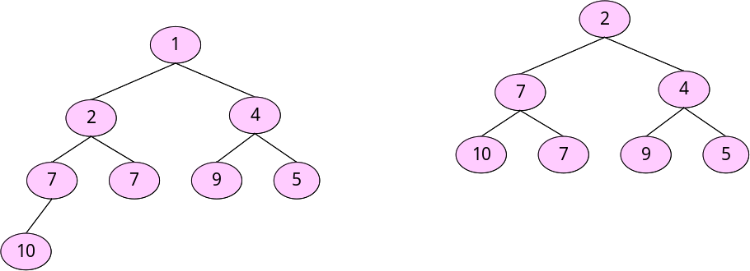
Array: {NULL,1,2,4,7,7,9,5,10} Array: {NULL,2,7,4,10,7,9,5}

QUESTION 5 Marks 7+2+1
Given the following definitions and the implementation of the ’Mystery’ function:
class Node  {  public: Node() ;  private:  int Key;  char Tag;  Node *leftChild;  Node *rightChild;  friend class binTree;  }; | class binTree  {  public:  void Mystery();  //other functions are here  private:  Node *root;  };
void binTree::Mystery()  {  Node *Arr[100];  int Top = 0;  Node *n = root;  Arr[Top++] = root;  while(Top>0)  {  n = Arr[--Top];  if (n->Tag == 'f')  {  n->Tag = 's';  Arr[Top++] = n;  n = n->rightChild;  }  else if (n->Tag == 't')  {  cout << n->Key << ' ';  }  else if (n->Tag == 's')  {  n->Tag = 't';  Arr[Top++] = n;  n=n->leftChild;  }  if (n && n->Tag != 't')  Arr[Top++] = n;  }  } | Key = 7  Tag =‘f’  Key =2  Tag =‘f’  Key = 1  Tag =‘f’  Key = 5  Tag =‘f’  Key = 4  Tag =‘f’  Key = 3  Tag =‘f’  Key = 6  Tag =‘f’  Key = 11  Tag =‘f’  Key = 9  Tag =‘f’  Key = 8  Tag =‘f’  Key = 10  Tag =‘f’  Key = 13  Tag =‘f’  Key = 12  Tag =‘f’  Key = 15  Tag =‘f’  Key = 14  Tag =‘f’
a. What will be the output of the Mystery() function when we run it on the tree shown in the figure?
14 7 12 13 6 3 15 11 10 5 9 8 4 2 1
b. What is it doing? RLV
c. What is its complexity? O(n)

